CAREMETRICS – HOSPITAL OPERATIONS ANALYTICS & PATIENT FLOW ANALYTICS
Data Analytics Internship Project Report

Project Title:
CareMetrics – Hospital Operations Analytics
Prepared by:
Vidya Subhash Boraste
Internship:
Data Analytics Internship
Organization Name:
Persevex Education
Project Duration:
4 Weeks
Tools Used:
- Python
- Pandas
- MySQL
- phpMyAdmin
- Power BI
Dataset:
Hospital Operations Dataset – 500 Patient Records

1. SUMMARY
CareMetrics – Hospital Operations and Patient Flow Analytics is a data analytics project developed to analyze hospital operational data and identify patterns related to patient flow, waiting time, bed utilization, length of stay, and patient satisfaction.
The project uses a synthetic dataset containing 500 patient records across 8 hospital departments and 3 admission types.
Python and Pandas were used for data cleaning, validation, transformation, and exploratory data analysis. MySQL was used to store and query the cleaned hospital data. Power BI was used to develop an interactive dashboard containing key performance indicators, department-level analysis, waiting-time analysis, occupancy analysis, monthly patient volume, and interactive filters.
The analysis found that the overall average patient waiting time was 174.07 minutes, average length of stay was 7.99 days, average bed occupancy was 57.15%, and average satisfaction score was 3.01/5.
Diagnostics represented the largest component of average waiting time, with an average delay of approximately 65.07 minutes.
The project demonstrates how a structured data analytics workflow can transform hospital operational data into meaningful insights for monitoring and operational planning.
2. INTRODUCTION
Hospitals generate large amounts of operational data through patient registration, consultation, diagnostics, billing, admissions, discharges, and bed utilization.
When this information is stored without proper analysis, it becomes difficult to identify operational bottlenecks and understand patient-flow patterns.
The CareMetrics project provides a structured analytical approach for examining hospital operations using Python, MySQL, and Power BI.
The project focuses on:
- Patient waiting time
- Service-stage delays
- Length of stay
- Bed occupancy
- Patient satisfaction
- Department performance
- Admission-type patterns
- Monthly patient volume
- High waiting-time cases
3. PROBLEM STATEMENT
Hospital operations involve multiple stages, and delays at any stage can affect the overall patient experience.
The major problem addressed by this project is the difficulty of analyzing hospital operational data in a structured and interactive manner.
The project aims to identify:
- Which departments have higher waiting times
- Which service stage contributes most to total waiting time
- How bed occupancy varies between departments
- How patient volume changes over time
- How admission types differ in operational measures
- The proportion of patients experiencing very high waiting times
- How patient satisfaction varies across operational groups
4.PROJECT OBJECTIVES
The main objectives are:
- To create a structured hospital operations dataset.
- To clean and validate hospital operational data using Python.
- To calculate important hospital KPIs.
- To analyze patient waiting time.
- To identify service-stage bottlenecks.
- To analyze department-level performance.
- To analyze bed capacity and occupancy.
- To analyze admission-type patterns.
- To analyze patient satisfaction.
- To identify high waiting-time cases.
- To store and query the data using MySQL.
- To develop an interactive Power BI dashboard.
- To provide data-driven operational insights.
- To demonstrate an end-to-end data analytics workflow.

5. PROJECT SCOPE
The scope of CareMetrics includes analysis of:
- Patient demographics
- Hospital departments
- Admission types
- Admission and discharge dates
- Registration waiting time
- Consultation waiting time
- Diagnostic waiting time
- Billing waiting time
- Total waiting time
- Length of stay
- Bed capacity
- Occupied beds
- Occupancy rate
- Patient satisfaction
The project covers data preparation, validation, exploratory analysis, SQL-based analysis, KPI development, dashboard development, and interpretation of results.
6. TOOLS AND TECHNOLOGIES
Tool | Purpose
Python | Data cleaning and analysis
Pandas | Data manipulation
MySQL | Data storage and SQL analysis
phpMyAdmin | Database management
Power BI | Dashboard and visualization
CSV | Dataset storage
DAX | Power BI KPI calculations

7. PROJECT WORKFLOW
The project follows an end-to-end analytics workflow:
Raw Dataset → Python Cleaning → Data Validation → Exploratory Data Analysis → MySQL Database → SQL Queries → Power BI → Dashboard → Insights
Step 1 – Data Collection
A synthetic hospital operations dataset was created for analytical and demonstration purposes.
Step 2 – Data Cleaning
Python and Pandas were used to check and clean the dataset.
Step 3 – Data Validation
The dataset was checked for missing values, duplicates, invalid dates, incorrect calculations, and inconsistent operational values.
Step 4 – Database Implementation
The cleaned dataset was imported into MySQL.
Step 5 – SQL Analysis
SQL queries were used to calculate patient counts, department performance, occupancy, waiting-time components, admission patterns, and high-wait cases.
Step 6 – Power BI
The cleaned dataset was connected to Power BI to create interactive visualizations and KPI cards.
Step 7 – Insight Generation
The results were interpreted to identify operational patterns and areas requiring attention.
8. DATASET DESCRIPTION
The project uses a synthetic hospital operations dataset containing 500 patient records.
The dataset contains 26 columns after data preparation.
Main fields include:
- Patient ID
- Age
- Gender
- Department
- Admission Type
- Admission Date
- Discharge Date
- Registration Wait
- Consultation Wait
- Diagnostic Wait
- Billing Wait
- Total Wait
- Length of Stay
- Bed Capacity
- Occupied Beds
- Occupancy Rate
- Satisfaction Score
- Calculated LOS
- LOS Difference
- Calculated Occupancy Rate
- Admission Month
- Admission Month Name
- Admission Day
- Age Group
- Calculated Total Wait
- Wait Difference
Departments
- Cardiology
- Dermatology
- ENT
- General Medicine
- Gynecology
- Neurology
- Orthopedics
- Pediatrics
Admission Types
- Emergency
- OPD
- Planned
9. DATA CLEANING AND VALIDATION
Python and Pandas were used to prepare the dataset before analysis.
The following checks were performed:
Validation Check | Result
Total Records | 500
Missing Values | 0
Duplicate Rows | 0
Invalid Dates | 0
Total Wait Mismatches | 0
LOS Mismatches | 0
Occupied Beds > Capacity | 0

Additional calculated fields were created to validate the original dataset.
These included:
- Calculated LOS
- LOS Difference
- Calculated Occupancy Rate
- Calculated Total Wait
- Wait Difference
- Age Group
- Admission Month
- Admission Month Name
- Admission Day
This validation helped ensure that the dataset was suitable for further analysis.
10. DATA QUALITY ANALYSIS
A separate data-quality analysis was included to improve the reliability of the project.
The dataset contained no missing values and no duplicate records.
Calculated fields were compared against the original fields to verify consistency.
For example:
Total Wait = Registration Wait + Consultation Wait + Diagnostic Wait + Billing Wait
The calculated results matched the original total waiting-time values.
Similarly, calculated length of stay and occupancy rates were validated against the original values.
This confirms that the cleaned dataset maintained internal consistency before being used in MySQL and Power BI.
11. KEY PERFORMANCE INDICATORS
The overall project KPIs are:
KPI | Result
Total Patients | 500
Average Wait Time | 174.07 minutes
Median Wait Time | 173 minutes
Average Length of Stay | 7.99 days
Average Occupancy | 57.15%
Average Satisfaction | 3.01 / 5

These KPIs provide a high-level overview of hospital operational performance.
12. WAITING-TIME ANALYSIS
Waiting time was divided into four major service stages.
Service Stage | Average Wait
Registration | 25.11 min
Consultation | 49.94 min
Diagnostics | 65.07 min
Billing | 33.95 min
Total | 174.07 min

Diagnostics represents the largest component of average waiting time.
It accounts for approximately 37% of the total average waiting time.
This makes diagnostics an important area for operational monitoring.
13. DEPARTMENT-WISE ANALYSIS
Department | Patients | Avg Wait | Avg Occupancy | Satisfaction
Cardiology | 65 | 170.55 | 58.01% | 3.18
Dermatology | 42 | 172.86 | 59.78% | 3.10
ENT | 61 | 177.93 | 51.09% | 2.72
General Medicine | 61 | 174.30 | 55.85% | 3.13
Gynecology | 67 | 183.45 | 61.90% | 2.93
Neurology | 72 | 172.94 | 54.80% | 3.18
Orthopedics | 75 | 171.57 | 61.64% | 2.92
Pediatrics | 57 | 168.32 | 53.57% | 2.91

Observations
Gynecology recorded the highest average waiting time at 183.45 minutes.
Pediatrics recorded the lowest average waiting time at 168.32 minutes.
Gynecology had an average occupancy of 61.90%.
Orthopedics had the highest number of patients with 75 records.
ENT recorded the lowest average satisfaction score at 2.72.
Cardiology and Neurology recorded the highest average satisfaction score at 3.18.

14. ADMISSION TYPE ANALYSIS
Admission Type | Patients | Avg Wait | Avg LOS | Satisfaction
Emergency | 148 | 176.53 | 7.71 | 2.97
OPD | 170 | 174.48 | 8.12 | 3.04
Planned | 182 | 171.70 | 8.08 | 3.01

The analysis shows differences in waiting time, length of stay, and satisfaction across admission types.
Planned admissions recorded the lowest average waiting time among the three categories, while Emergency admissions recorded the highest average waiting time.
15. AGE GROUP ANALYSIS
Age Group | Patients | Avg Wait | Avg LOS | Satisfaction
0–18 | 113 | 174.75 | 8.39 | 2.87
19–35 | 99 | 178.95 | 7.85 | 3.03
36–50 | 71 | 176.52 | 8.24 | 3.00
51–65 | 101 | 167.44 | 8.00 | 3.21
66+ | 116 | 173.53 | 7.54 | 2.96

The 19–35 age group had the highest average waiting time at 178.95 minutes.
The 51–65 age group had the lowest average waiting time at 167.44 minutes.
This analysis provides an additional demographic perspective on hospital operational patterns.
16. MONTHLY PATIENT VOLUME ANALYSIS
Month | Patients
January | 89
February | 72
March | 105
April | 79
May | 79
June | 76

March recorded the highest patient volume with 105 patients.
January recorded the highest average occupancy at approximately 60.94%.
Monthly analysis helps identify changes in patient volume and capacity utilization.
17. BED OCCUPANCY ANALYSIS
Overall:
- Average Bed Capacity: 40.03
- Average Occupied Beds: 22.54
- Average Occupancy: 57.15%
Department-level occupancy ranged from approximately 51% to 62%.
Gynecology had an average occupancy of approximately 61.90%, while ENT had approximately 51.09%.
The analysis can help administrators monitor department-level capacity utilization.
18. HIGH WAITING-TIME ANALYSIS
Patients with total waiting time greater than 240 minutes were classified as high-wait cases for this analysis.
Result:
High-Wait Patients: 32
Total Patients: 500
High-Wait Percentage: 6.4%
This provides an additional operational KPI that can be monitored through the dashboard.
19. PATIENT SATISFACTION ANALYSIS
The satisfaction scores ranged from 1 to 5.
Satisfaction Score | Patients
1 | 98
2 | 107
3 | 95
4 | 93
5 | 107

Average satisfaction was approximately 3.01/5.
The distribution shows that all five satisfaction categories are represented in the dataset.
20. CORRELATION ANALYSIS
Correlation analysis was performed to examine relationships between selected operational variables.
Variable Pair | Correlation
Wait vs Satisfaction | -0.047
LOS vs Satisfaction | -0.065
Occupancy vs Satisfaction | -0.025
Wait vs LOS | 0.005

The correlations are close to zero.
Therefore, the dataset does not show a strong linear relationship between these variables.
These results should be interpreted as associations within this synthetic dataset, not as evidence of causation.
21. SQL DATABASE AND ANALYSIS
The cleaned hospital operations dataset was imported into a MySQL database named hospital_analytics. The hospital_operations table was created to store the cleaned dataset. SQL queries were used to analyze patient volume, department performance, bed occupancy, waiting-time components, admission types, monthly patient volume, and high waiting-time cases.
Figure 1: MySQL Hospital Operations Table
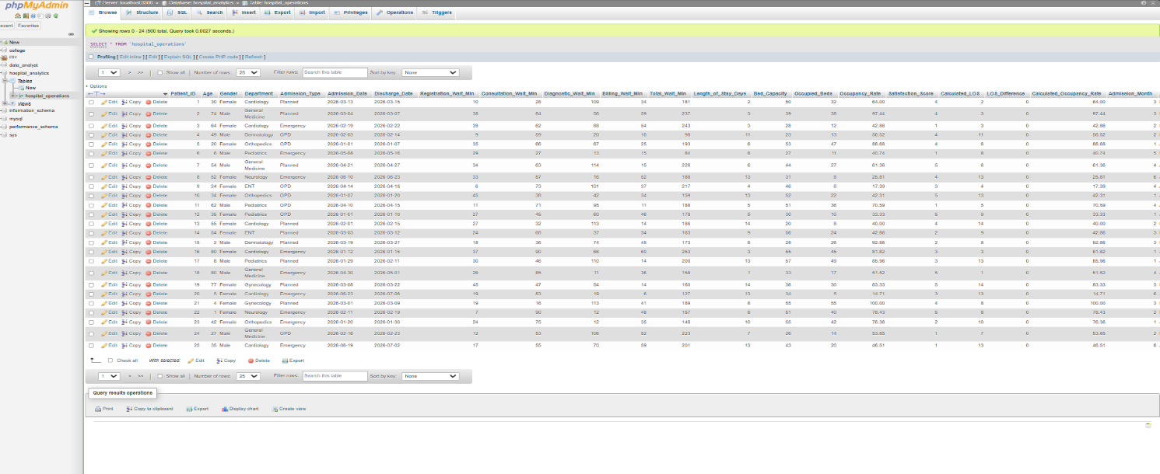
Figure 2: Total Patients
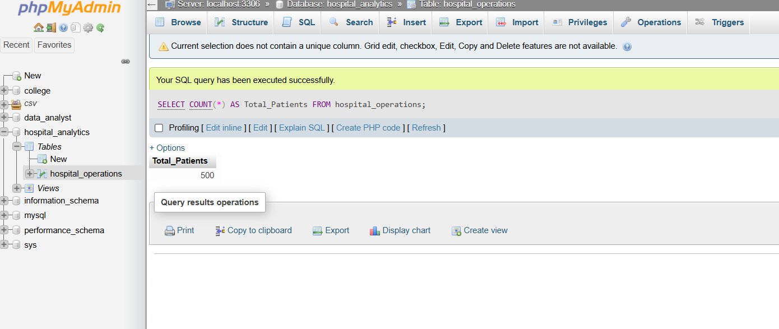
Figure 3: Overall Hospital Summary
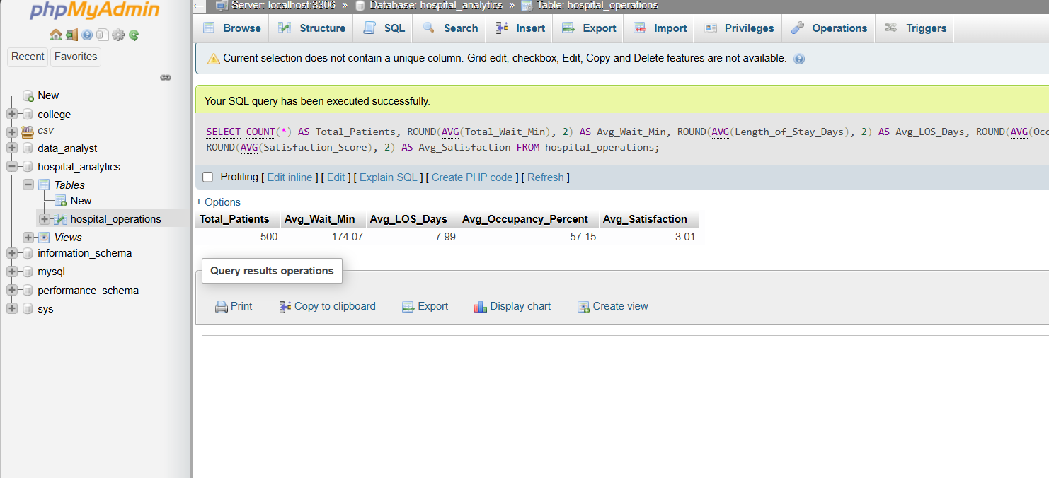
Figure 4: Department-wise Analysis
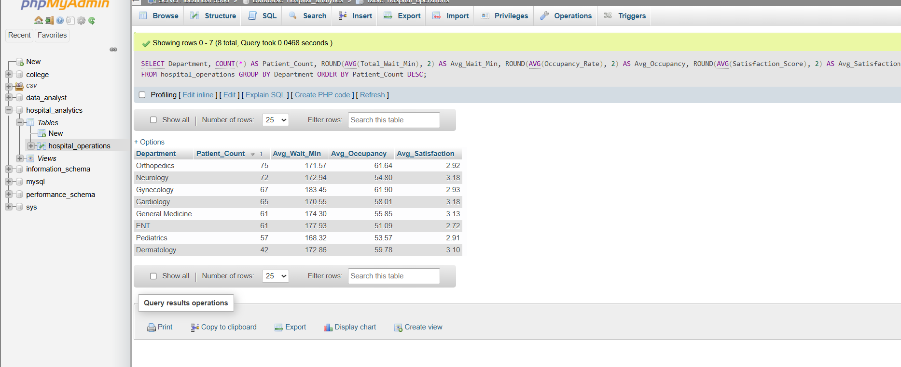
Figure 5: Waiting-Time Analysis
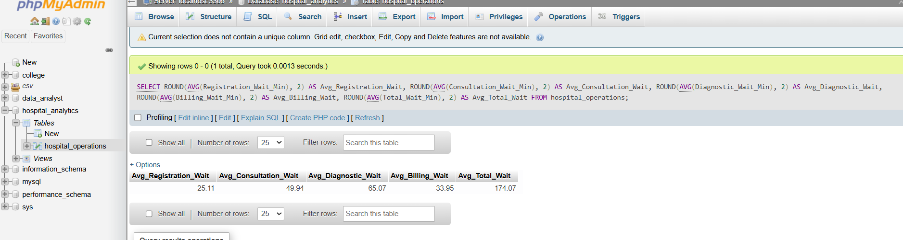
Figure 6: Occupancy Analysis
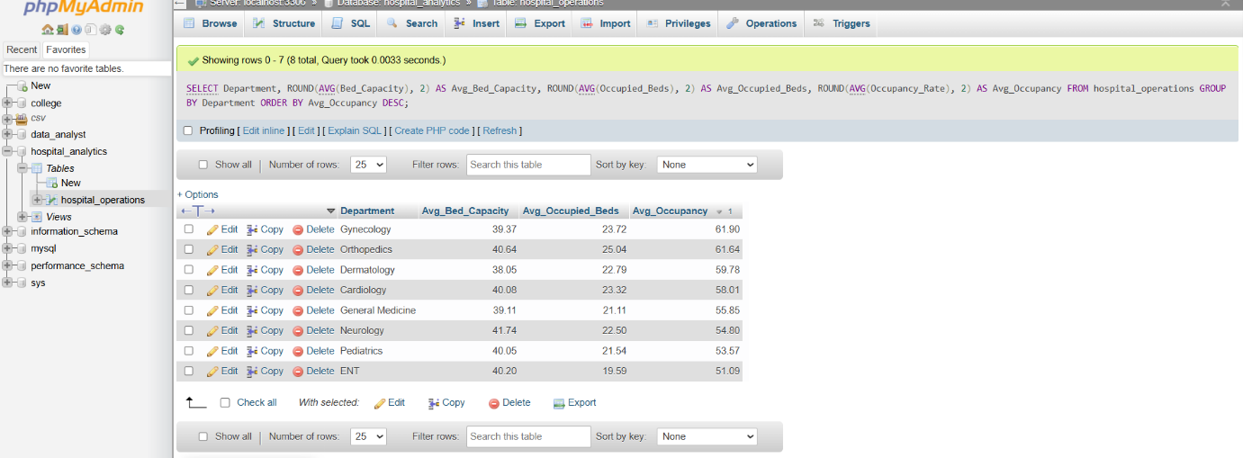
Figure 7: Admission Type Analysis
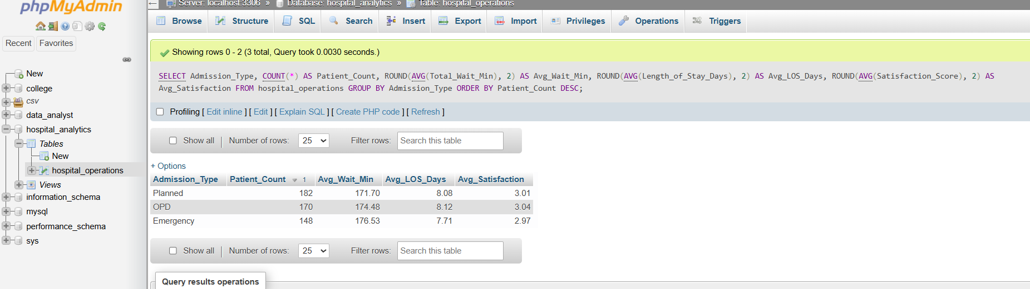
Figure 8: Monthly Analysis
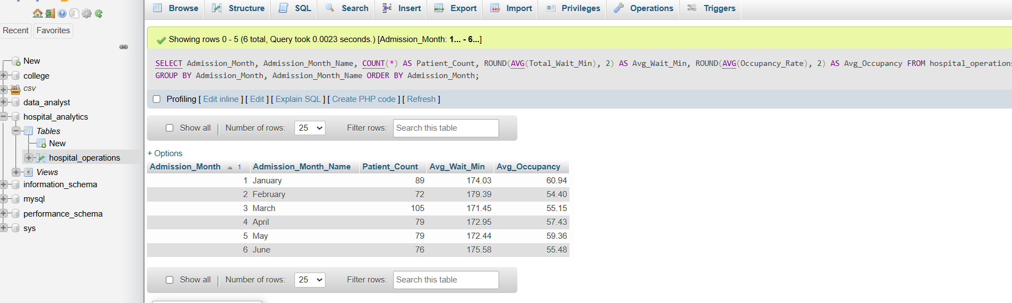
Figure 9: High Wait Analysis
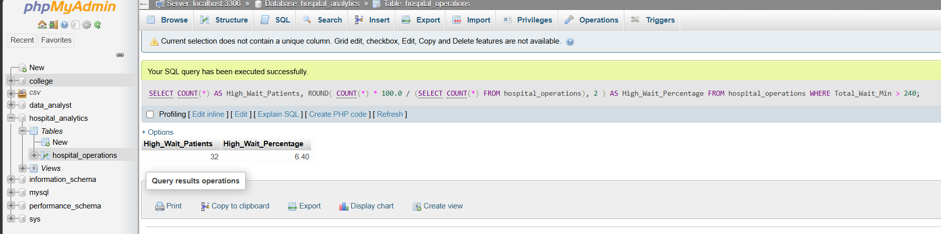

22. POWER BI DASHBOARD
An interactive Power BI dashboard was developed to provide a consolidated view of hospital operational performance. The dashboard includes KPI cards for total patients, average waiting time, average length of stay, average occupancy, and average patient satisfaction. It also contains department-wise analysis, waiting-time components, monthly patient volume, and occupancy analysis. Interactive slicers for Department, Admission Type, and Gender allow users to explore the data dynamically.

Figure 10 : CareMetrics Power BI Dashboard
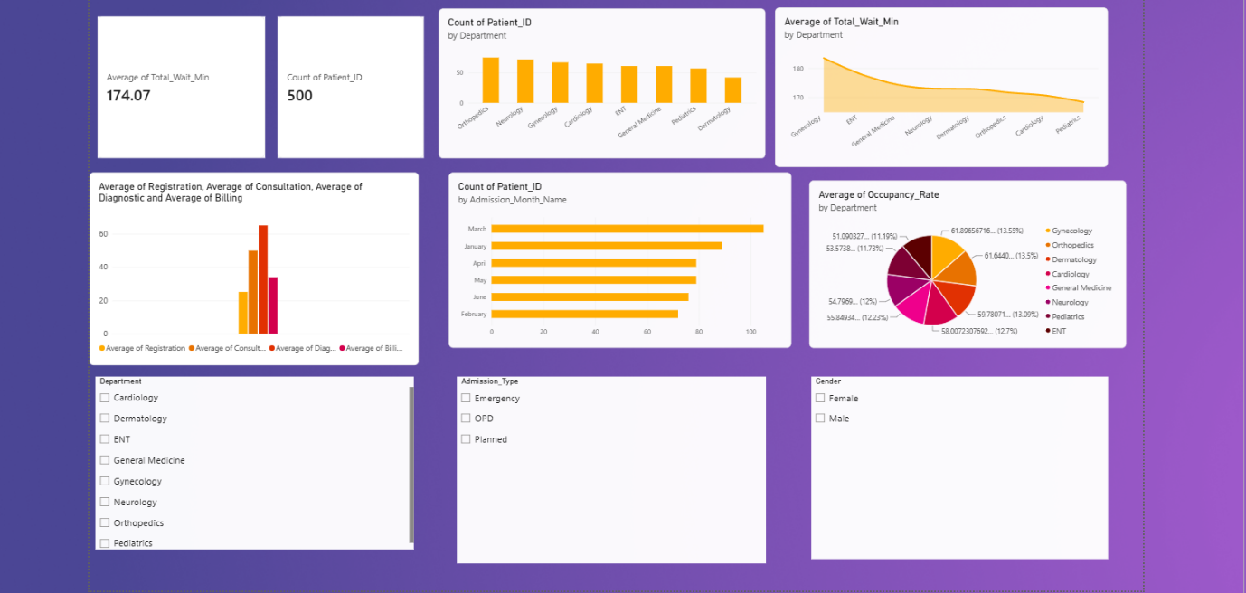
The dashboard provides a visual and interactive way to monitor hospital operations and identify important patterns in patient flow, waiting time, capacity utilization, and satisfaction.

23. DASHBOARD DESIGN
The dashboard was designed to provide both high-level KPIs and detailed operational analysis.
The top section provides summary KPIs.
The middle section presents department and waiting-time analysis.
The lower section provides monthly volume and occupancy analysis.
Interactive slicers allow users to filter the dashboard according to department, admission type, and gender.
This design allows users to move from an overall hospital view to more detailed operational patterns.
24. KEY FINDINGS
The major findings from the project are:
- The dataset contains 500 patient records.
- Average patient waiting time is 174.07 minutes.
- Average length of stay is 7.99 days.
- Average occupancy is 57.15%.
- Average satisfaction is 3.01/5.
- Diagnostics has the highest average waiting component at 65.07 minutes.
- Gynecology has the highest average department waiting time at 183.45 minutes.
- Pediatrics has the lowest average department waiting time at 168.32 minutes.
- March has the highest monthly patient volume with 105 patients.
10. 32 patients, or 6.4% of the total patients, have waiting times above 240 minutes.
11. Gynecology has the highest average occupancy at approximately 61.90%.
12. Orthopedics has the highest patient volume with 75 patients.
13. Correlations between major operational variables are weak in this dataset.
25. RECOMMENDATIONS
Based on the analysis, the following operational areas can be monitored:
- Monitor diagnostic waiting time because it contributes the largest portion of total waiting time.
- Review workflows in departments with higher average waiting times.
- Monitor department-level occupancy regularly.
- Track monthly patient volume to understand changes in demand.
- Monitor high-wait cases above 240 minutes.
- Track patient satisfaction together with operational KPIs.
- Use Power BI filters for department-level performance monitoring.
- Continue using SQL queries for structured operational analysis.
These recommendations are based on the patterns observed in the synthetic dataset and should not be interpreted as actual hospital policy recommendations.
26. LIMITATIONS
The project has the following limitations:
- The dataset is synthetic and created for analytical purposes.
- The dataset does not represent actual hospital performance.
- Detailed real-time hospital information was not available.
- The analysis does not include actual doctor schedules or staffing rosters.
- Correlation analysis does not establish causation.
- Waiting-time components are based on the available operational fields.
- The project is designed as a demonstration of a data analytics workflow.
27. FUTURE SCOPE
The following features were not implemented in the current version of CareMetrics but can be considered for future development.
Real-Time Data
Future versions can connect the dashboard to live hospital databases.
Predictive Analytics
- Machine learning models could be developed to predict:
- Patient volume
- Waiting-time risk
- Bed occupancy
- Demand patterns
Automated Alerts
- Alerts could be created for:
- High waiting time
- High occupancy
- Unusual patient volume
- Department congestion
Advanced Dashboard
- Future dashboards could include:
- Doctor-level analysis
- Hourly patient flow
- Staff utilization
- Appointment scheduling
- Real-time occupancy
- Monthly trend analysis
Hospital System Integration
The project could eventually be connected with hospital management systems to provide more automated operational monitoring.
28. PROJECT DELIVERABLES
The final project contains:
- Raw Dataset
- Cleaned Dataset
- Python Cleaning Script
- Python Analysis Script
- MySQL Database
- SQL Import File
- SQL Analysis Queries
- Power BI Dashboard
- Project Report
- Screenshots of SQL Results
- Screenshot of Power BI Dashboard
29. CONCLUSION
CareMetrics demonstrates an end-to-end data analytics workflow for hospital operations.
The project uses Python for data preparation and analysis, MySQL for structured data storage and SQL analysis, and Power BI for interactive visualization.
The analysis provides insights into patient waiting time, service-stage delays, department performance, admission types, patient volume, bed occupancy, satisfaction, and high waiting-time cases.
The project demonstrates how raw operational data can be transformed into structured information, analytical insights, and an interactive dashboard.
Because the dataset is synthetic, the results should be considered a demonstration of the analytical methodology rather than measurements of real hospital performance.

